Name:______________________ Lab Time:_______________________
ICND1 LAB - TCP and UDP Packets in the Transport Layer

Background
The two protocols in the TCP/IP Transport Layer are the transmission control protocol (TCP), and user datagram protocol (UDP). Both protocols support upper-layer protocol communication. For example, TCP is used to provide Transport Layer support for the HTTP and FTP protocols, among others. UDP provides Transport Layer support for domain name services (DNS) and trivial file transfer protocol (TFTP), among others.
The ability to understand the parts of the TCP and UDP headers and the protocol operation are a critical skill for network engineers.

Task 1: Identify UDP header fields and operation using a Wireshark DNS session capture.
The UDP protocol is referred to as a non-reliable protocol. This doesn’t mean it is a bad protocol; it just means that UDP doesn’t attempt to verify if a sent packets arrived correctly, in the correct order, or even if they arrived at all. No delivery verification as attempted (although, error checking can be done to ensure a packet is received without corruption).
In this task, we will capture packets involved in a DNS lookup. DNS communication utilizes UDP rather than TCP.

Step 1: Capture a DNS session.
- Start a Wireshark capture on the Intel interface on your computer. If you have trouble with this step, let instructor know.
- In your Administrative Command prompt, use the ipconfig and ping commands as shown below to obtain an address from DNS and then send test messages:

- When finished, stop your Wireshark capture.

Step 2: Filter your Wireshark Display
If you have more than just DNS packets (and you probably will), you may create a display filter to show only packets containing DNS.
- In the filter field at the above the packet list pane, enter udp.port==53 and click “Apply”.
Why did we specify UDP port 53 to filter our captured packets in order to see only DNS traffic?

Step 3: Analyze the UDP fields.
Look at your Wireshark capture. Your capture should be somewhat similar to the following capture:
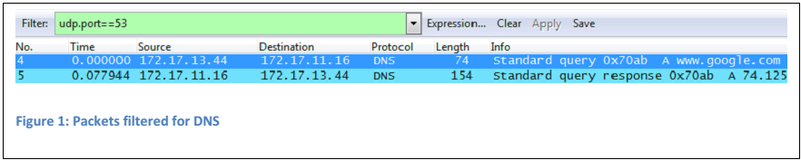
Recall that in Wireshark, detailed UDP information is available in the Packet Detail Pane.
- Highlight the DNS datagram that contains the request for the address of www.google.com from your computer (listed as “Standard query” in the packet list pane).
- In the packet detail pane of Wireshark expand the UDP header by clicking on the protocol expand box. It may be necessary to adjust the middle window. The expanded UDP datagram should look similar to the following:

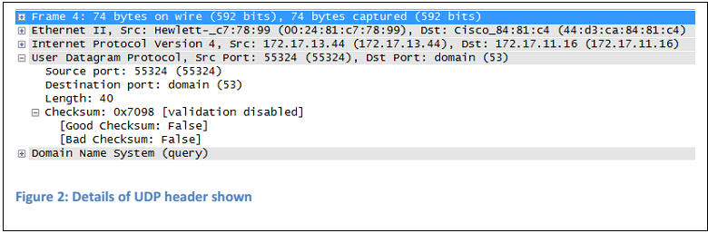
Notice that each UDP datagram identifies the UDP source port and UDP destination port.

- Using your Wireshark capture of the DNS Address Query packet (a request from your computer), fill in information about the packet: Port numbers come from the UDP header; IP addresses come from the IP header:

Source IP address:
Destination IP address:
Source Port number:
Destination Port number:

- Highlight the captured DNS datagram that contains the response with the address of www.google.com from the DNS server (“Standard query response…”). Fill in information about the UDP header:

Source IP address:
Destination IP address:
Source Port number:
Destination Port number:

- Compare the source port in the first packet to the destination port in the second packet. How are these source and destination ports related? Explain why that is.

Task 2: Identify TCP header fields and operation using a Wireshark FTP session capture.
TCP sessions are well controlled and managed by information exchanged in the TCP header fields. In this task, a FTP session will be made to the classroom FTP server. Note: these steps assume you are in one of the network labs on NWTC’s campus.

Step 1: Capture an FTP session.
- Open a command line window bu run „cmd“ in Start -> find.
- Start a new Wireshark capture.
- Back in the command window, start an FTP connection to the free FTP server. Type the command:

C:\> ftp 199.204.44.194

- When prompted for a user id, type anonymous. When prompted for a password, press ENTER.
- After you are connected, terminate the FTP sessions in each command line window with the FTP quit command:

ftp > quit

- Stop the Wireshark capture. You may close the command prompt if you wish.
While we didn’t do anything “useful” with the FTP server, we have generated network traffic we can now analyze to see how TCP operates.

Step 2: Filter Wireshark to show only packets with your IP address
In this step you will configure a Display filter in Wireshark to show only packets coming from or go to your station’s IP address. As the process is similar to that performed earlier in this lab, fewer details will be provided.
- Enter a packet filter rule of “ip.addr==youripaddress” where youripaddress is the IP address assigned to your machine; for example ip.addr==172.17.13.153. Apply your filter.

You might still have other packets (coming from or going to your machine) so we will also filter the packets in an additional way.

- Right click on the first packet from your IP address to the IP address 172.17.11.16 and then select Follow TCP Stream. A new window will open showing an interpreted version of the conversation. Go ahead and close this “Follow TCP Stream” window. Wireshark will now show only those packets involved in the “conversation”. Notice that your filter string will become tcp.stream eq 0. Your actual stream number may be different; this is ok.

Step 3: Analyze the TCP fields.
TCP is routinely used during a session to control datagram delivery, verify datagram arrival, and manage window size. Every time an FTP client contacts an FTP server, a new TCP session is started. At the conclusion of the data transfer, when the FTP session is finished, TCP performs an orderly shutdown and termination.
- If necessary, switch to the Wireshark window.
- Highlight the first TCP datagram from your computer; this packet should have the ftp port (21) as the destination port and have ONLY the Synchronization (SYN) bit set.
- In the packet details pane, expand the TCP header by clicking on the protocol expand box. It may be necessary to adjust the size of the details pane to see everything. The expanded TCP datagram should look similar to the following figure:

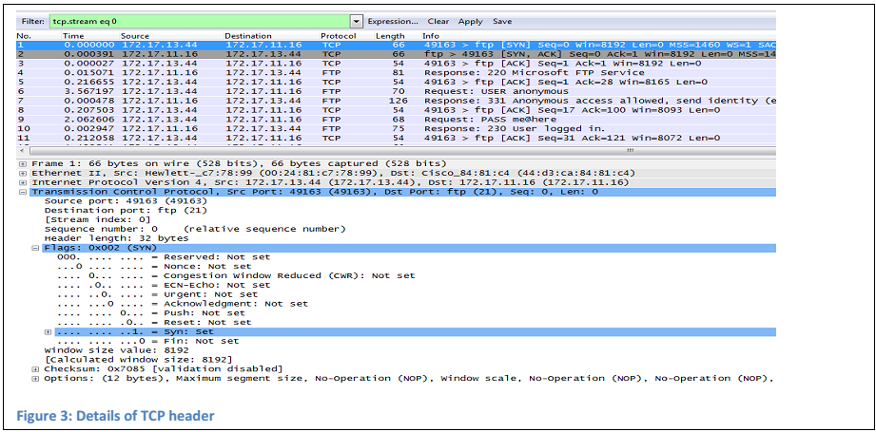

How is the first datagram in a TCP session identified (e.g., what flags are set to a value of 1)?

If necessary, refer back to the lecture notes and/or the book for an explanation of each field.

- What are the source and destination IP address for the first packet from your computer to the FTP Server (only the SYN bit is set to 1); note that IP addresses will come from the packet summary or the IP header:

Source IP address:
Destination IP address:
TCP Sequence number:
TCP Acknoledgement number: NOT PRESENT IN THIS PACKET

- Fill in information about the second packet from the FTP Server back to your computer (only the SYN and ACK bits are set to 1):

Source IP address:
Destination IP address:
TCP Sequence number:
TCP Acknoledgement number:

- Fill in information about the third packet from your computer to the FTP Server (only the ACK bit is set to 1):

Source IP address:
Destination IP address:
TCP Sequence number:
TCP Acknoledgement number:

At this point the 3-way handshake has occurred between the two machines, the sequence numbers on each side have been synchronized, and the actual conversation is ready to start. Do not close your
Wireshark session!

Task 3: TCP Sequence/Acknowledgment Number Analysis

Background
We will now use Wireshark to examine the relationship between Sequence numbers and Acknowledgement numbers.

Looking at Seq, Ack, and bytes in flight
We have already looked at the 3-way handshake; we don’t need to consider those packets in our conversation.

- Change your display filter so that it not only specifies the tcp.stream but also includes the
requirement that the packet have FTP information. Your filter should read

tcp.stream eq 0 and ftp

Recall that the actual tcp.stream value you have in your capture may be different than the one shown in my example. After adding the ftp requirement, your screen should appear similar to the following:

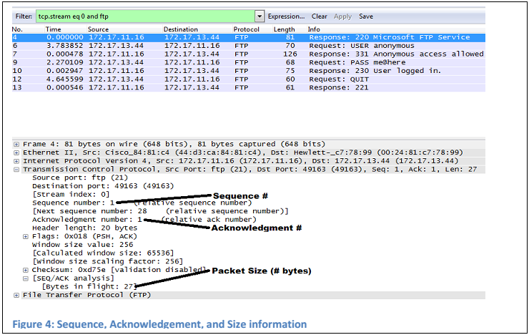

In Figure 4, the first packet after the handshake is selected and the details of the TCP header as well as the [SEQ/ACK analysis] details shown inside the header have been expanded. Inside the details of the TCP header, Wireshark shows the Sequence number, acknowledgement number, and number of bytes in this packet.
- In your packet capture (from the FTP session you captured and filtered above), select the first packet shown. This is actually the first packet after the 3-way handshake. If necessary, expand out the Transmission Control Protocol header and the [SEQ/ACK analysis] details inside the TCP header. Fill in the following table for this packet:

Source IP address:
Destination IP address:
TCP Sequence number:
TCP Acknoledgement number:
Packet size:

- What will the sequence number of the next packet sent from this source machine in this conversation be? Hint: add the number of bytes to the sequence number.

- Select the next packet in the conversation. This should have the source and destination IP
addresses switched; that is, the packet is moving the “other direction”. Again, fill in the following table:

Source IP address:
Destination IP address:
TCP Sequence number:
TCP Acknoledgement number:
Packet size:

- How is the Acknowledgement number sent from machine B to machine A (in the table from Step 18) related to the sequence number sent from machine A to machine B (in the table from Step 16)? In other words, what does the number in an acknowledgement represent?

- Select the next packet in the conversation. This should have the same source and destination IP addresses as those from the first packet after the handshake (those addresses seen in the table in Step 16). Once more, fill in the following table:

Source IP address:
Destination IP address:
TCP Sequence number:
TCP Acknoledgement number:
Packet size:

- How does the Sequence number in this third table relate to your predicted “next sequence” number you calculated in Step 17? In other words, was your prediction correct?

- View the details of several other packets in the conversation. Keep track of the direction the packet is moving (e.g., watch the source & destination addresses) and the Sequence & Acknowledgement numbers to ensure your reasoning about the relationship of the Acknowledgement and Sequence numbers is correct.

- When finished, close your Wireshark capture.

